A

Report

On

ONE DAY SECIAL LECTURE

Session : 2021-22

Department of Philosophy & Mthamertics

Rabindra Mahavidyalaya,

Champadanga, Hooghly

Theme:Story of Time and Timelessness (অকালের সন্ধানে )”

Venue: YOUTUBE LIVE
Online ZOOM

Date:22.07.2021 (Thursday, 7:30 pm onwards)

Joint Organizer: jointly organized by Department of Mathematics & Philosophy along with
IQAC & IT Sub-Committee, Rabindra Mahavidyalaya

Objectives:
- To promote understanding via explanations of particularly difficult concepts.
- To respond to student misconceptions or difficulties.
- To create or engage interest in a new area.
- To synthesize information across a range/variety of material.
- To give a clear understanding of various subjects
- For the development of thinking
- A rise in students' self-assurance and intelligence
- Development of Discussion skills, engage in meaningful discussion to arrive at a shared understanding, exhibit independence and flexibility of thought, and time management

BROCHURE
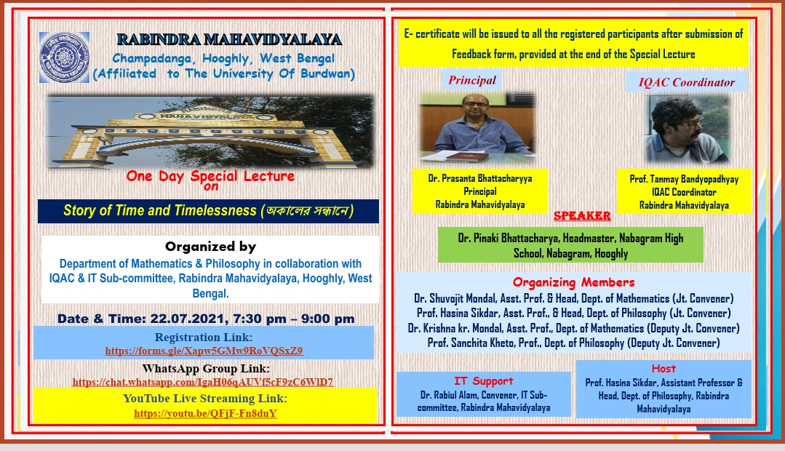

summery
A One Day special lecture was successfully organizedon 22/7/2021,It was jointly organized by Department of Mathematics & Philosophy along with IQAC & IT Sub-Committee, Department of Philosophy and IQAC. One Day special lecture topic wasStory of Time and Timelessness (অকালেরসন্ধানে)”. The speaker was Dr. Pinaki Bhattacharya, Headmaster, Nabagram High School,Nabagram, Hooghly.one day special lecture was hosted by prof. Hasina Sikdar Assistant Professor & Head, Department of Philosophy, Rabindra Mahavidyalaya. Welcome address by Dr. Krishna kumar Mondal, Assistant Professor, Department of Mathematics, Rabindra MahavidyalayaInaugural speech was given by Dr. Prasanta Bhattacharyya the principal of the college. He talked about the theme of the lecture and he also encouraged us to organize such as special lecture frequently. Introduction speech was given by Professor Tanmoy Bandyopadhyay associate prof. commerce and IQAC coordinator.

Then special lecture session started by the main speaker Dr. Pinaki Bhattacharya, Certificates were issued to the registered participants. At the end of the topic discussion, the question Answer session was held by Dr. Shuvojit Mondal, Assistant Professor & Head, Department of Mathematics, RabindraMahavidyalaya. The participants were very satisfied with this session. The one-day special lecture ended with a vote of thanks by prof. Sanchita Kheto, Professor, Department of Philosophy, Rabindra Mahavidyalaya

Special Lecture on “Story of Time and Timelessness (অকালেরসন্ধানে )”
jointly organized by Department of Mathematics & Philosophy along with
IQAC & IT Sub-Committee, Rabindra Mahavidyalaya

Date: 22.07.2021 (Thursday, 7:30 pm onwards)
Speaker: Dr. Pinaki Bhattacharya, Headmaster, Nabagram High School,
Nabagram, Hooghly

Topic: Story of Time and Timelessness(অকালেরসন্ধানে)

Programmed Schedule (Duration: 1 Hr. 30 Mints

- 7:30 pm- 7: 32pm: Welcome address by (Dr. Krishna kumar Mondal,
Assistant Professor, Department of Mathematics, Rabindra Mahavidyalaya)
- 7:33pm-7:38pm: Inaugural Speech by Principal (Dr. Prasanta Bhattacharyya,
Principal, Rabindra Mahavidyalaya)
- 7:39pm-7:44pm: Introductory Speech by IQAC Coordinator (Prof. Tanmay
Bandyopadhyay, IQAC Coordinator, Rabindra Mahavidyalaya)
- 7:45pm- 8:35pm: Speaker (Dr. Pinaki Bhattacharya, Headmaster,
Nabagram High School, Nabagram, Hooghly)
- 8:36pm- 8:54pm: Question & Answer session by (Dr. Shuvojit Mondal,
Assistant Professor & Head, Department of Mathematics, Rabindra
Mahavidyalaya)
- 8:55pm- 9:00pm: Vote of Thanks by (Prof. Sanchita Kheto, Professor,
Department of Philosophy, Rabindra Mahavidyalaya)
- Hosting: Prof. Hasina Sikdar, Assistant Professor & Head, Department of

Philosophy, Rabindra Mahavidyalaya

- IT Support: Dr. RabiulAlam (Convener, IT Sub-committee, RabindraMahavidyalaya)
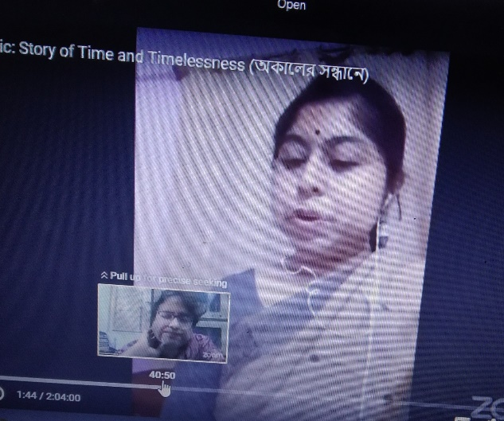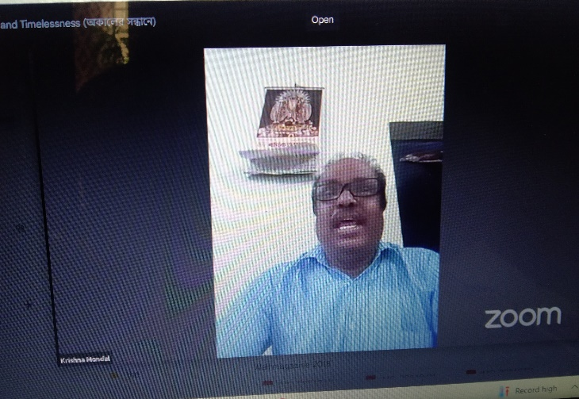
Hosti: Prof. Hasina SikdarWelcome address by Dr. Krishna kumar Mondal
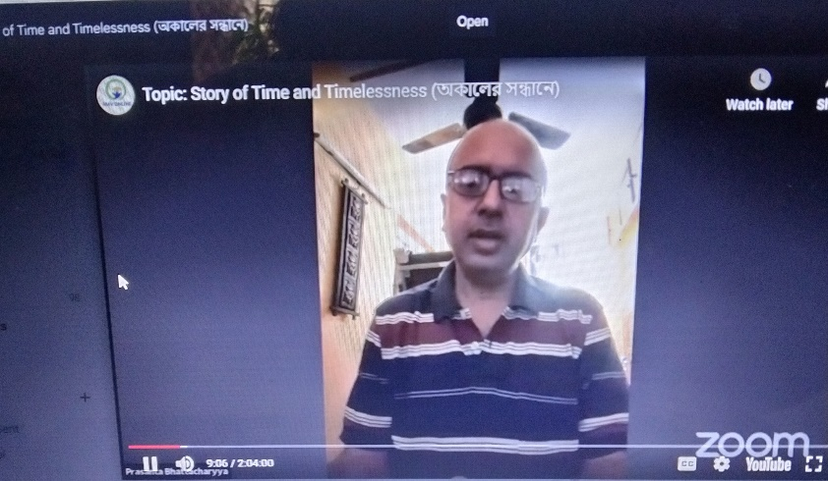
Inaugural Speech by Principal :Dr. Prasanta Bhattacharyya
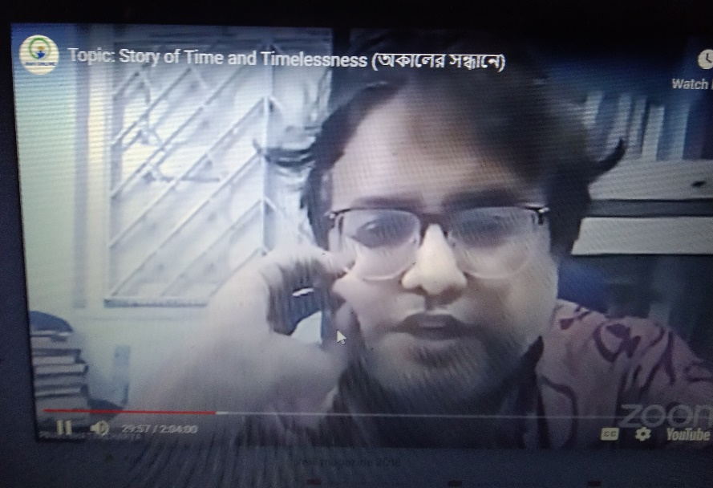
Speaker:Dr. Pinaki Bhattacharya, Headmaster
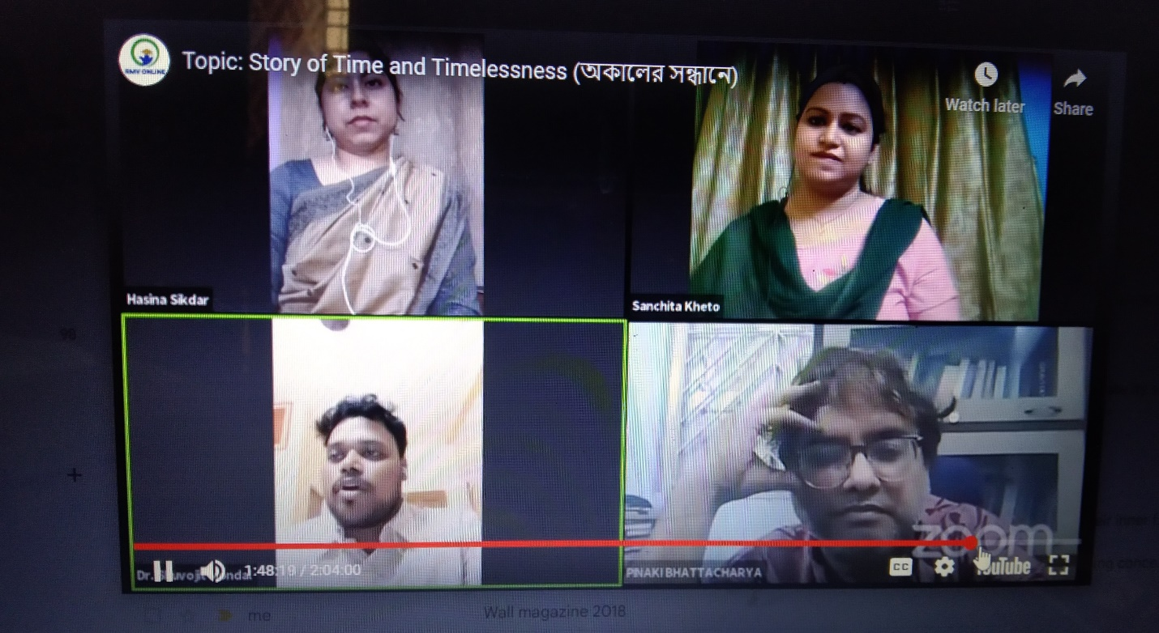
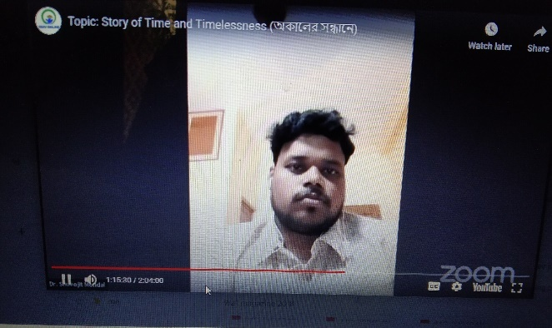
Question & Answer session by Dr. Shuvojit Mondal
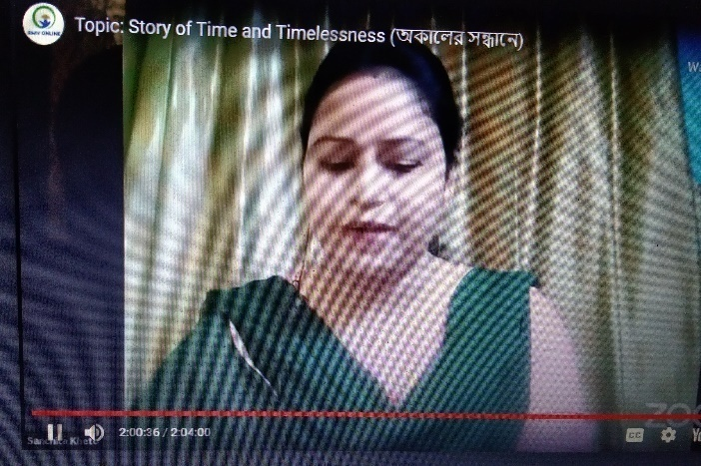
Vote of Thanks by Prof. SanchitaKheto,

WEBINER RESPONSE: 222
MALE: 70
FEMALE: 152

WEBINER FEEDBACK summary:
- 80% Satisfactory
- 90 % opined the webinar session helped to improve their academic performance
- 70 % wished to occur the series more
Some feedback from participant:
- Want more such this kind of topic, which is related to our daily life
- This is the very important topic of your one day lecture in the critical lockdown situation of the world.
- Very helpful session,
- Please conduct another special lecture like this
- If you can provide better sound and video system
- arrange webinar about ethical value

